**Missingness for all variables**

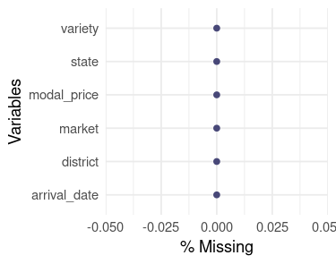

**Validation results using the validator library**

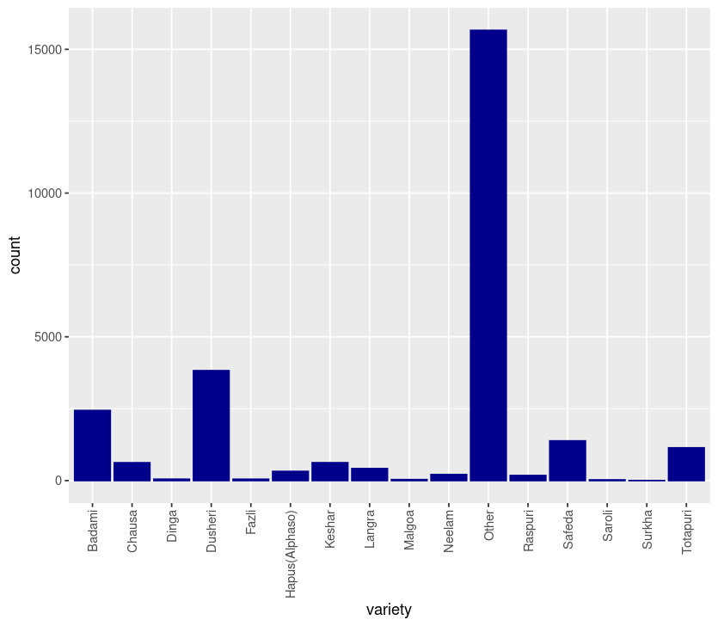

**Variable importance plot**

